BUSINESS ANALYSIS CASE STUDY
BBT Group
Requirements Analysis for a Construction Management System
Project type | Academic team project, 2025
My role | Business Analyst
Client | BBT Group (construction & plumbing contractor, Bloemfontein)
BBT Group is a construction and plumbing contractor that had grown for over a decade while still running core operations manually — through phone calls, WhatsApp, and email. Our team was tasked with analysing this problem and specifying a web-based construction management system to replace it. This case study presents the business analysis behind that project: the problem diagnosis, the requirements work, and the resulting recommendation.
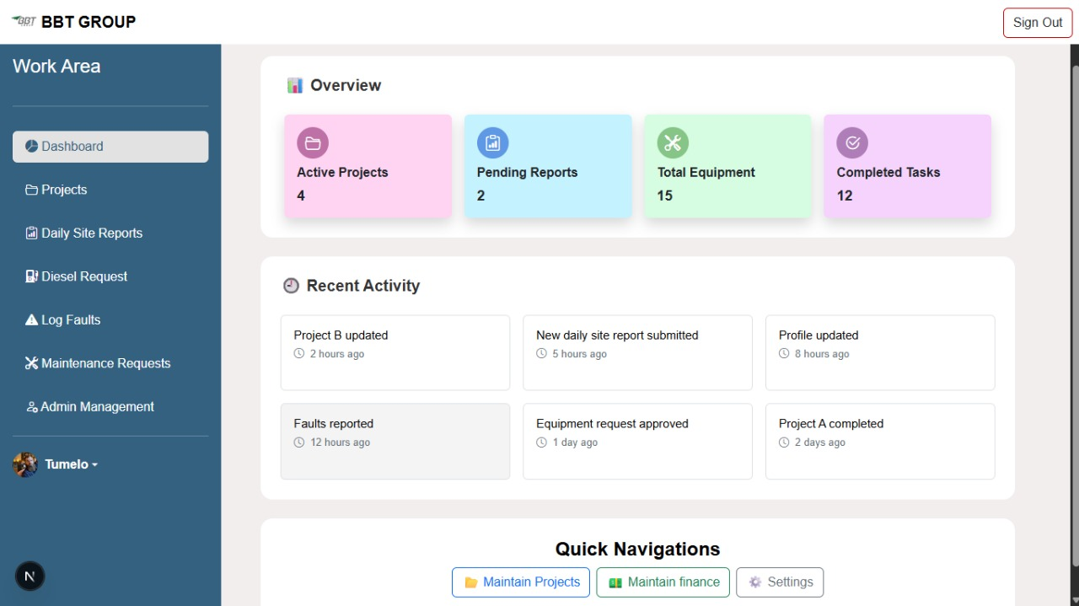
Operations Dashboard — provides a centralised view of project progress, financial performance and key operational activities.
BUSINESS PROBLEM
Situation & Complication
Situation
BBT Group is a construction and plumbing contractor based in Bloemfontein, South Africa, operating for over 11 years. Despite this track record, core business processes were still run manually: project communication over phone and WhatsApp, quotes and invoices handled by email, and no shared record of budget versus actual spend across projects.
Complication
A structured interview with BBT's contracts manager (11 years in the role, responsible for client consultation, project budgeting, and team briefing) surfaced five specific problems with the current way of working:
- No central record of project documents — difficult collaboration between site teams and suppliers
- No consistent way to track progress or resource use across concurrent projects
- Communication spread across calls, WhatsApp, and email — causing double-bookings and missed deadlines
- Manual invoicing — causing payment discrepancies and delays
- Sensitive company and client data shared over channels with no access control or encryption
Together, these findings framed the business problem: BBT could not scale project volume without also scaling operational risk, unless these processes were centralised.

BUSINESS ANALYSIS APPROACH
From Interview Findings to Requirements
The interview findings were treated as a starting point, not a specification. Each issue raised was tested against what it implied for a system — what data was involved, who needed to see or approve it, and what would go wrong if left unaddressed. This analysis was scoped and validated before any interface design began, using four requirements artifacts:
1. Context diagram
Defined the boundary of the system and confirmed the four user roles — Admin, Operations Manager, Site Manager, and General User — with the client before further analysis.
2. Use case diagram
Mapped each of the five business problems to the specific actions each role needed access to, so requirements could be traced back to a role and a purpose.
3. Class diagram
Defined the core objects in the system — projects, requests, workflows, users — and how they relate, forming the structural link between requirements and the data model.
4. Data model (ERD)
Translated the finance and reporting requirements raised in the interview into a structured entity relationship diagram of 14 entities, covering projects, requests, workflows, and financial records.
These are presented here as evidence of the analysis process, not as illustrations — each diagram was a working artifact used to validate scope.
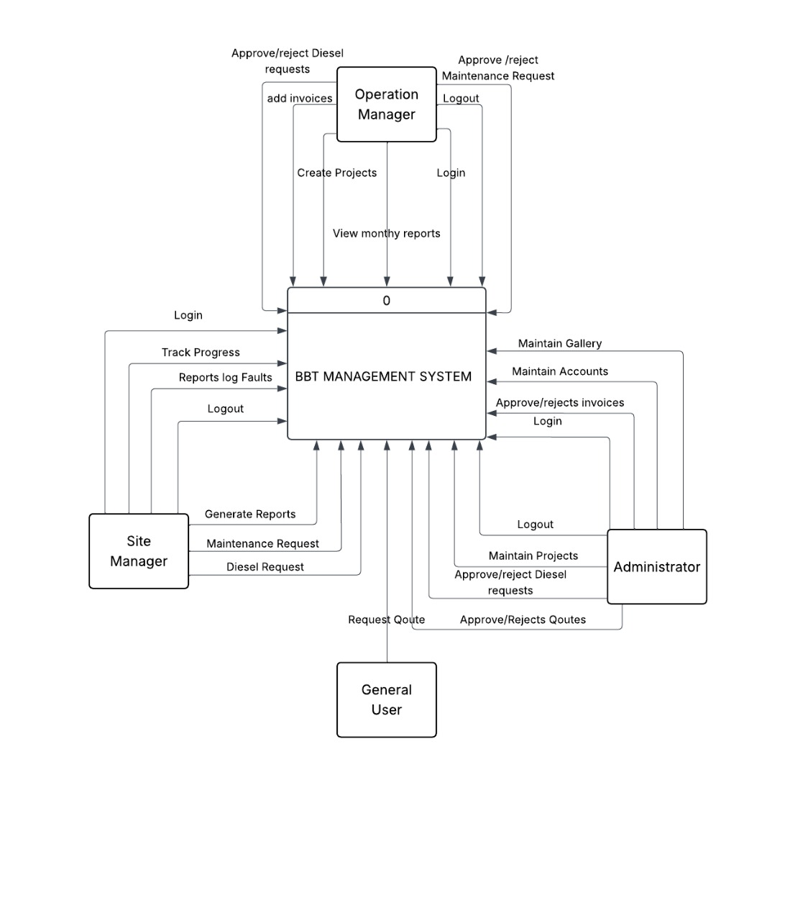  Context diagram | 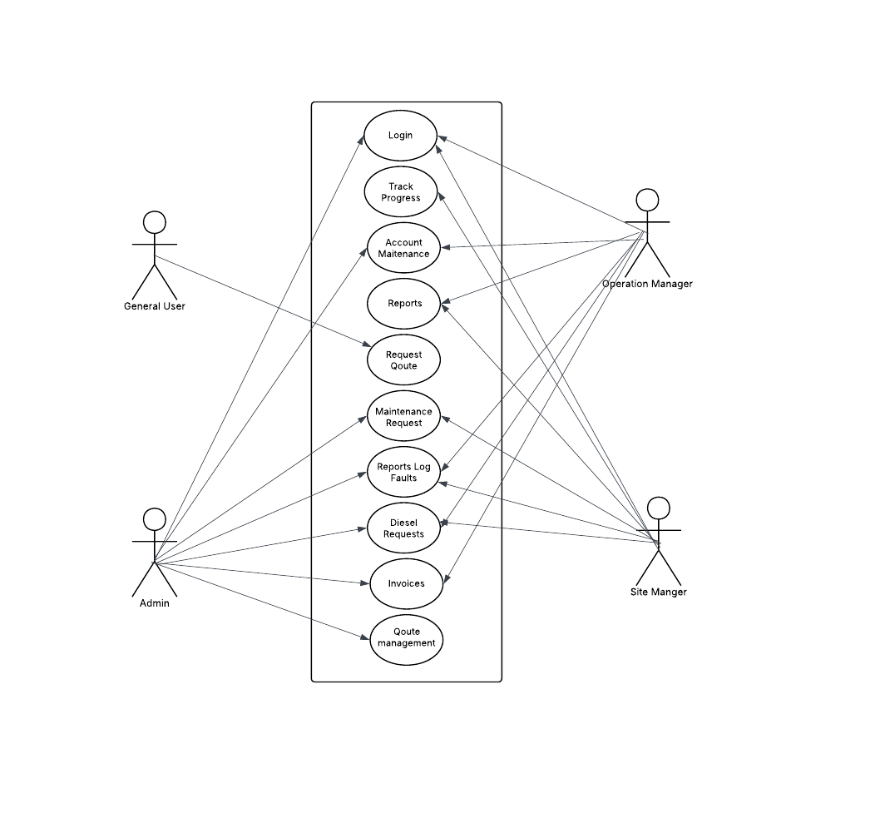  Use case diagram — role-based access

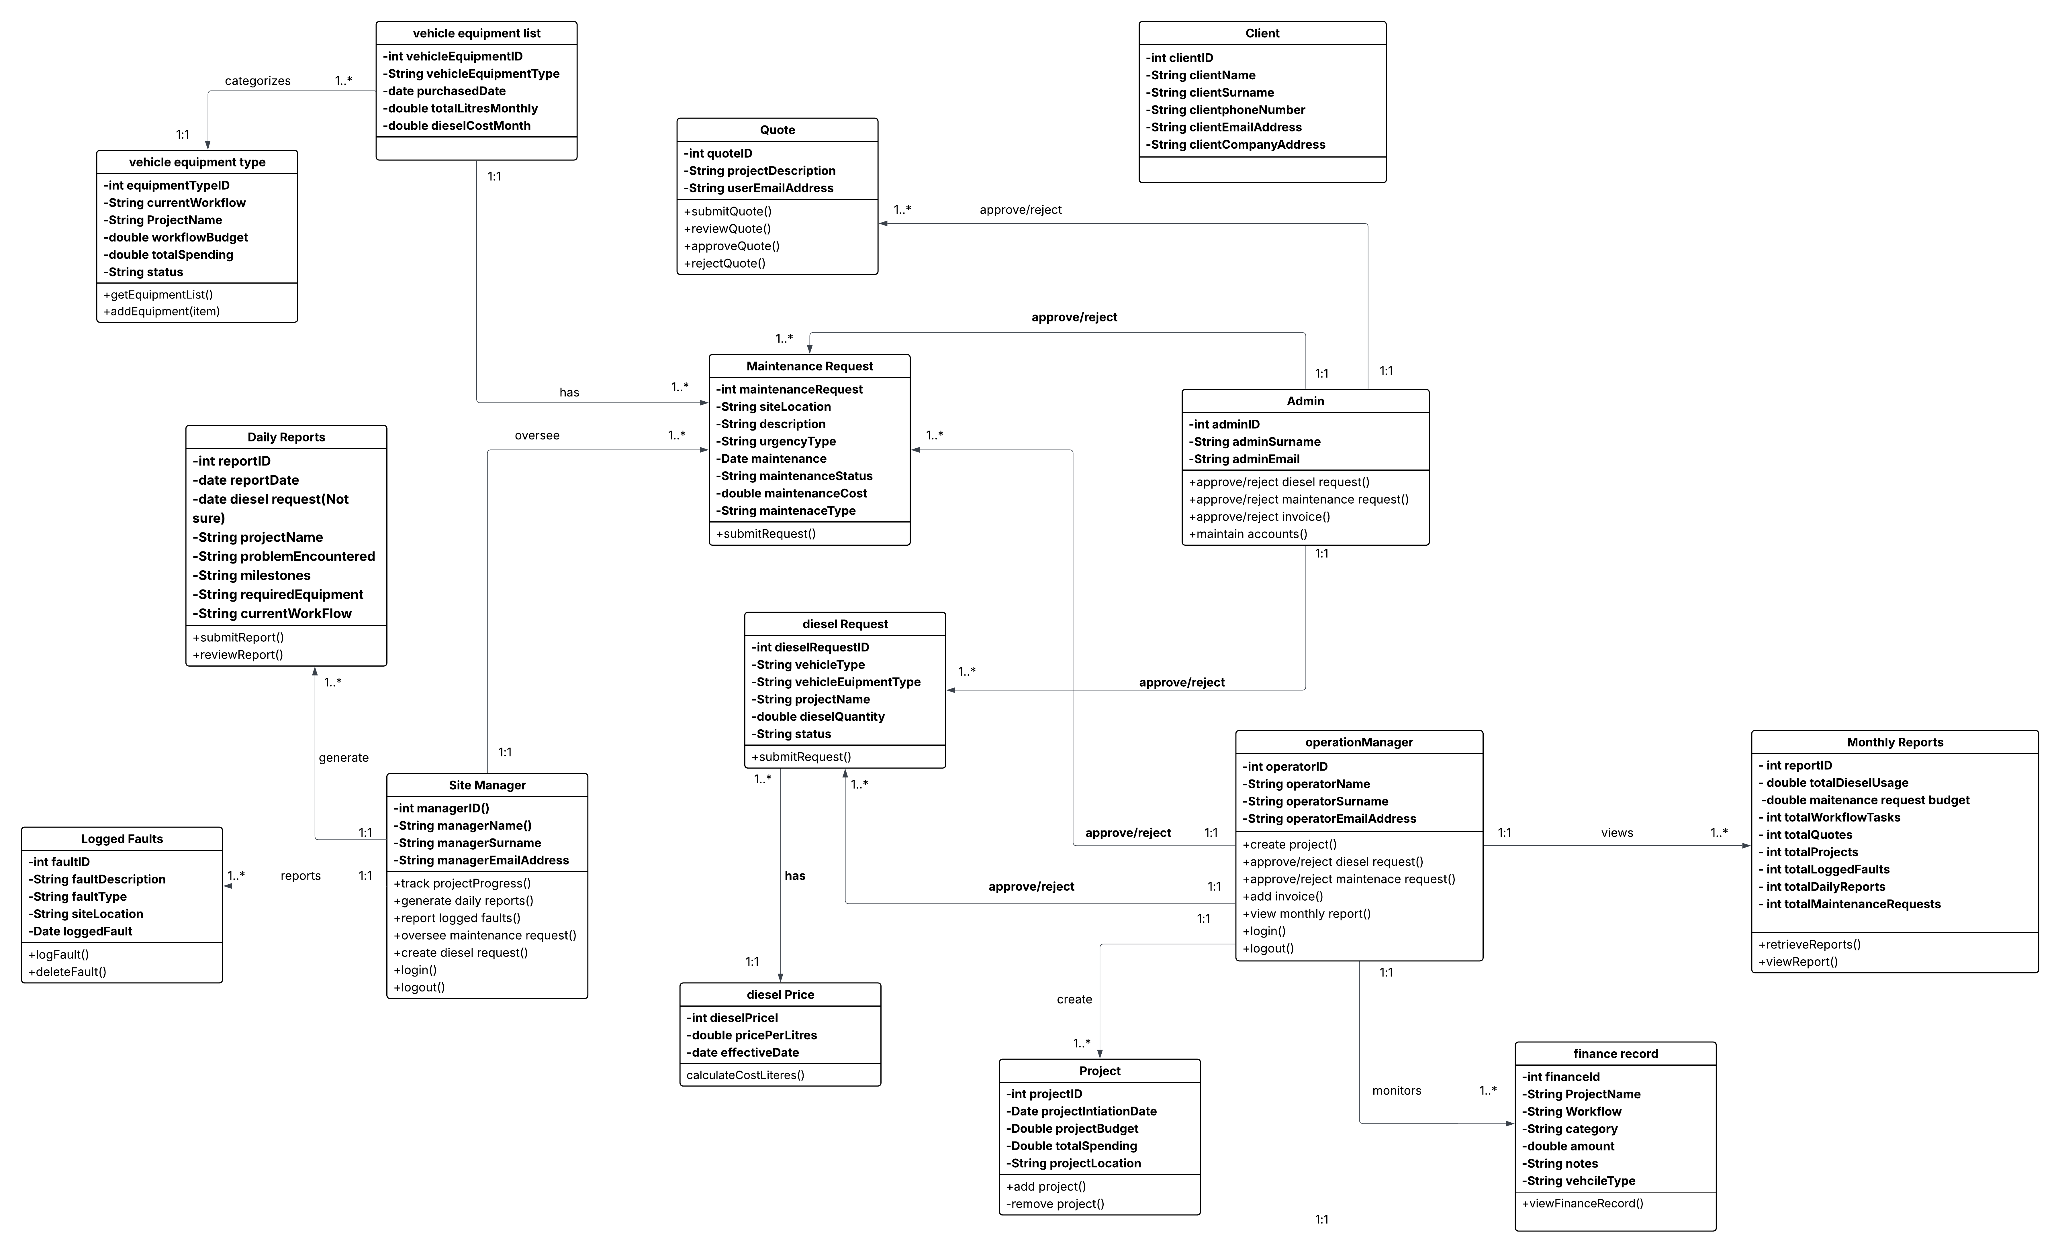  Class diagram — core system objects | 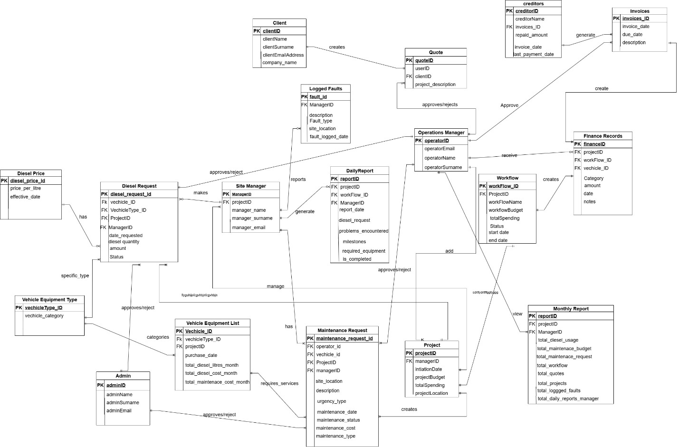  Data model — finance and reporting requirements

REQUIREMENTS → PROPOSED SOLUTION
Key Requirements and Recommendation
Each of the five business problems was translated into a specific system requirement. The recommendation to BBT centred on three priorities, chosen because they addressed the highest-impact problems raised in the interview:
Project dashboards
Real-time progress and budget-vs-spend visibility per project — addressing the lack of a consistent way to track project status and resource use.
Structured request/approval workflow
A defined process for diesel and maintenance requests, replacing manual invoicing and creating an audit trail of who requested and approved what.
Role-based access control & security
Access restricted by role, with encryption for financial and client data — a direct response to the lack of any access control in the current WhatsApp/email-based workflow.
The finance requirement was grounded in real operating data rather than assumption: for example, one vehicle's diesel use and cost, and a separate equipment service cost, were tracked in the source project's finance data — figures that existed only as receipts before this analysis. That level of detail is what turned a general need for "financial tracking" into a specification: which fields were needed, what needed to be totalled, and who needed visibility into it.
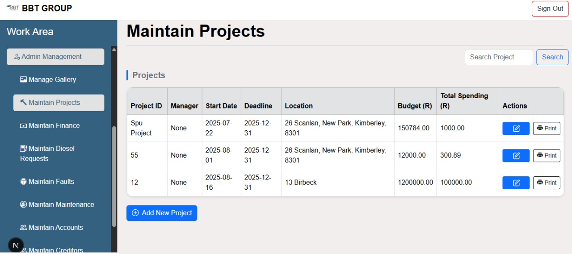  Project dashboard — budget vs. spend per project | 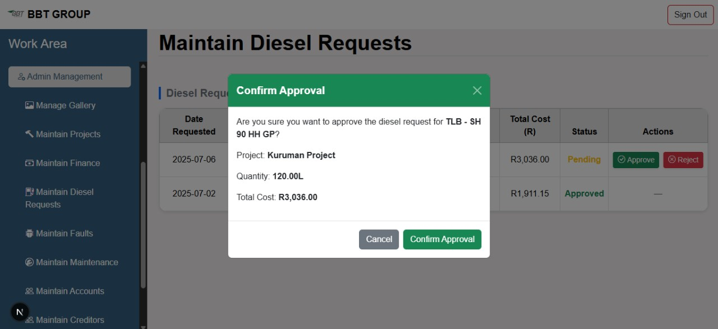  Request/approval workflow — diesel request approval

MY CONTRIBUTION
Business Analysis Skills Demonstrated
This was a team project; the platform design and build were a group effort. My assigned role on the team was Business Analyst, covering the requirements work below.
BA Skill | Where it is demonstrated
Stakeholder engagement | Took part in the stakeholder interview with BBT's contracts manager, asking questions that helped surface requirements from an unstructured conversation.
Problem structuring | Helped separate the five issues raised in the interview into distinct, addressable requirements, grouped by functional and non-functional need.
Analytical accuracy | Helped ground the finance requirement in real operating data (recorded diesel usage and maintenance costs) rather than assumption.
Communication (technical & non-technical) | Contributed to the context diagram, use case diagram, and data model used to validate scope with the client and hand off to the technical build.
Recommendation & business case | Helped connect each of the three system recommendations back to a specific problem raised in the interview, rather than a generic feature list.

CONCLUSION
Business Value & Project Evidence
The proposed system directly addresses the five problems identified in the initial analysis: it centralises project documentation, gives visibility into progress and spend across projects, replaces fragmented communication with structured workflows, removes manual invoicing errors, and secures sensitive data behind role-based access control. For a business that had scaled for over a decade without changing how it operates, this was the analysis that connected a set of everyday frustrations to a specific, scoped system requirement.
Project Evidence
- This document summarises the business analysis contribution to a larger academic team project.
- Full project documentation — including the complete requirements specification, all diagrams, and the system design — is available separately on GitHub.
- This project was completed as part of a university team of five; the platform design and development were a shared team effort.

